McMaster Humanities Society

Fall 2021 Term
Meeting Number: 5

Date: 14 September 2021

Start time: 4:00 pm EST

In Attendance:
- Alexandra (President)
- Akosua (Admin)
- Aislinn (Internal)
- Taylor (Marketing Interim)
- Naomi (marketing Interim)
- Finn (External)
- Madeline (Operations)
- Marlene (Finance)

Not in Attendance:
- Archana (Academics)

Minutes
Alexandra (President):
- A big thank you to the team for collaborating and putting effort into Back to School events!
- Check-in with Finn about his external team (make sure that the Wellness Coordinator, Nicole, has her Wellness Wednesday post ready to go up this week and fills out the Caring Communities Network form by Sept. 20 - explain to the rest of the exec what this network is).
  - Nicole has registered us for CCN- student groups join this, elect a representative to go through training so that they can better support students within the student group/body
  - Wellness Wednesday- Nicole to post for WW either tomorrow or next week
  - Claire has posted for Elections

- I will have the nomination forms for VP Marketing and FYRs updated on our website by this Friday and will post the links to them on our socials this Friday (people will have to submit their forms by Fri. Sept. 24 and attend an all-candidates meeting on Sat. Sept. 25 before they start campaigning on Sept. 27)
  - Link to be posted on link tree on Friday
  - Candidates meeting on 25th September before 6pm EST
- Jenna wants to set up a meeting with Cristina, MHS Execs and Clubs under the MHS (execs of their choice)
  - Options sent on When2Meet
  - Polling website to be used to determine the best dates for this meeting (3 best times)
    - Tuesday, September 28th at 3:00PM
    - Tuesday, September 28th at 4:00PM
    - Thursday, September 30th at 4:00PM
    - Friday, October 1st at any time
    - Tuesday, October 5th at 4:30PM
    - Thursday, October 7th at 3:00PM
    - Thursday, October 7th at 4:00PM

- Check-in with all of the execs who didn't send in minutes for updates and for brainstorming ideas for the year.

Madeline (Operations):
- announcing date and time for our first fall event, the virtual bonfire (I will be sending out a signup sheet with event shifts for execs)

  - Friday October 1, 7pm—9pm
  - Proposal to be posted in LinkTree

- quick update on my peripheral team first year position: applications open on Wednesday and close on the 24th

Marlene (Finance):
- I have meeting minutes - just to go overall the general budget, and to discussion an email I got from Eng about sponsorships! 5-10mins roughly
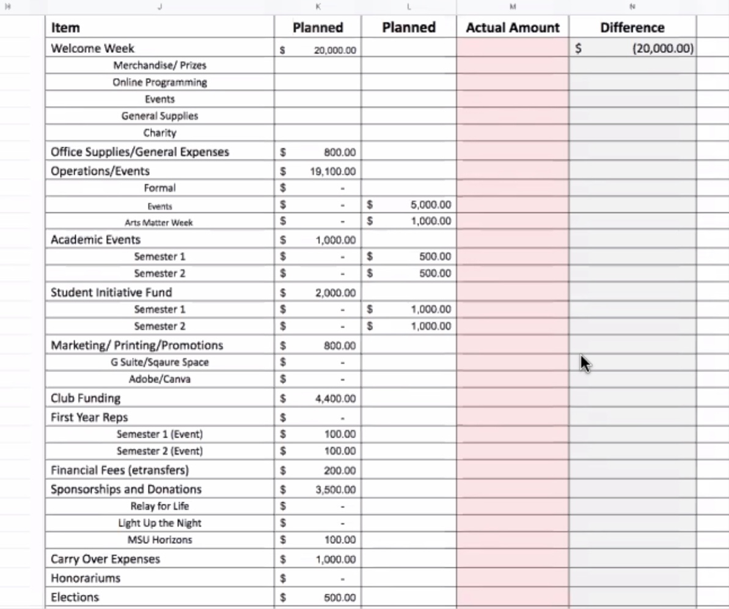

Aislinn (Internal):
- budget for clubs

  - total of $500.00 proposed budget- Aislinn
  - Marlene- clubs to be sent emails to fill out reimbursement forms
  - Reach out to Underground for clarification for reimbursement

- 2nd year welcome recap
  - Welcome was a success!

- working on: student groups, constitutions, thank you to navy nation

Akosua (Admin):
- uploading Newsletter to website/ social media accounts~ granting public access
- Marketing to put out a graphic to encourage students to check out the Newsletter!

(Interim Marketing):

Finn (External):

End Time: 4:40 EST

